Database Tuning
CS5226

A0079953L – LEE ZHONG DE ROLLEI

TABLE OF CONTENT
Question 1: Block Packing Factor (PCTFree) 2
Question 2: Table Fragmentation 6
Question 3: Index Reorganization 8

Question 1: Block Packing Factor (PCTFree)
The init.ora has a Db_block_size = 8192. DB_BLOCK_SIZE specifies (in bytes) the size of Oracle database blocks used for each datarow in the datatable.
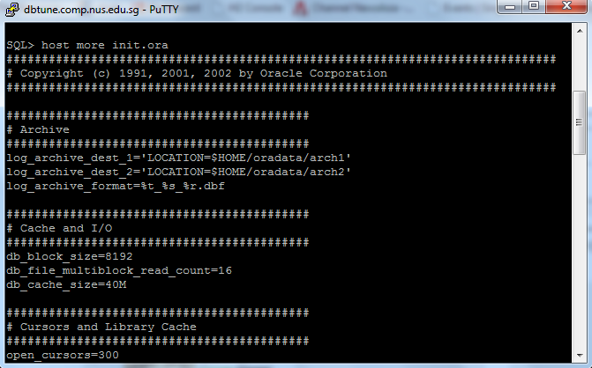

q1-create.sql (as below) creates a table (table1) with PCTFREE parameter set to 5. PCTFREE parameter specifies the percentage of space in each data block that is reserved for future update of existing data.

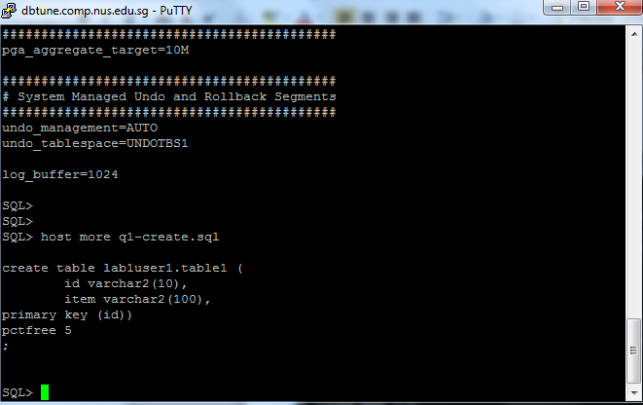

q1.sql insert 5000 rows to table1 and perform and subsequently update column “item” in table 1
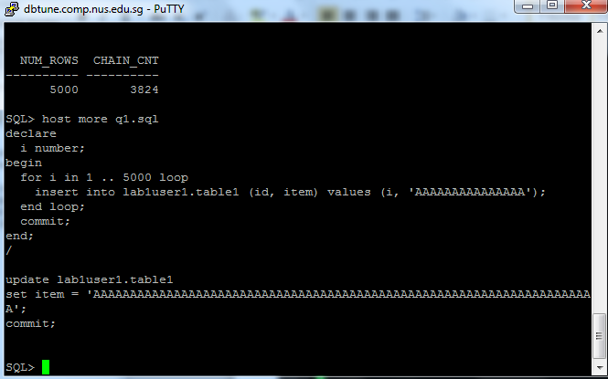
q1-check.sql shown that the update from q1.sql has resulted in 3824 chained rows.

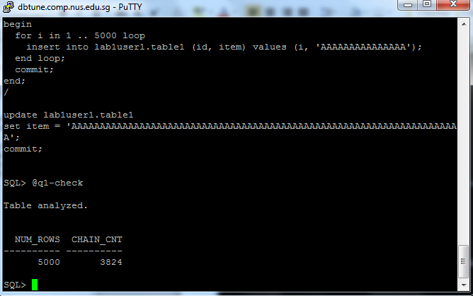

To avoid chained records, we drop and re-create table1 with PCTFree set to 70%

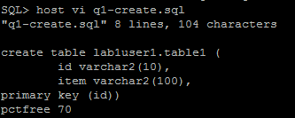

Proceed to execute q1-create.sql, q1.sql and q1-check.sql. After changing the PCTFree parameter from 5% to 70%, the update occurred in q1.sql did not consequently create any chain rows

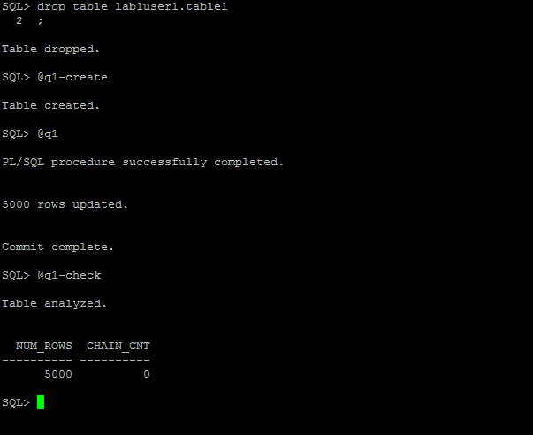
Question 2: Table Fragmentation
- Execute q2.sql to create table 2
- Execute q2-analyze.sql to analyze the chained rows in table
- Count the number of chained_rows in table 2

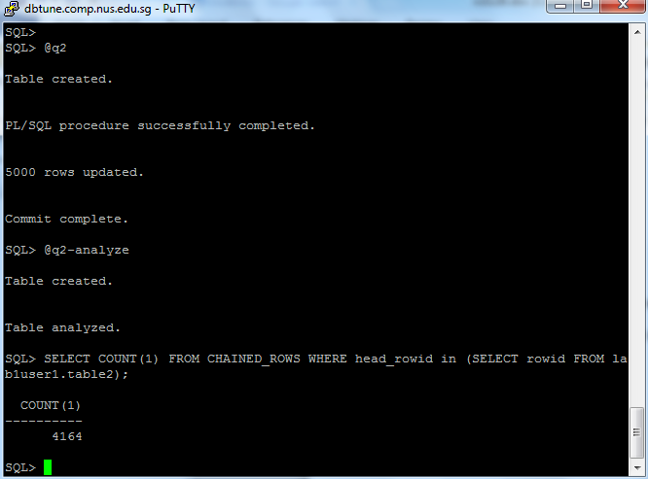
To eliminate the chain rows, a temporary table is created to store the chained rows in table2. The chained rows were then deleted from table2. Finally, the chained rows in the temporary table were transferred back. This will consequently eliminate the chained_rows in table2 while preserving the original data.

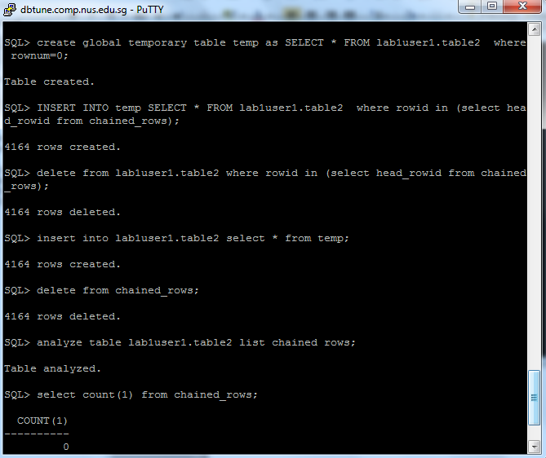
Question 3: Index Reorganization

The index created has a ratio (number of deleted entries to the number of current entries) of 26% as shown below. As such, it should be re-organized to achieve a ratio less than 20%.

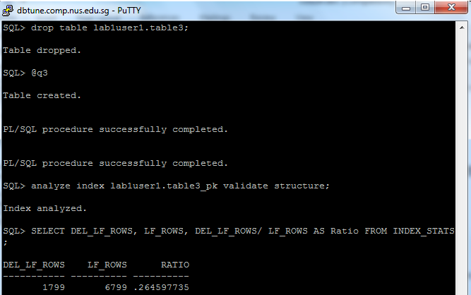

After rebuilding the index, the ratio has not bee reduced to 0%

